
r

Exor Corporation Limited

Maintenance Manager

Inspection Loader v4.3



The Global Leader in

Infrastructure Asset Management


This page intentionally blank

Quality Assurance Statement

Document Details
File:  Maintenance Manager Inspection Loader.pdf | Prepared by:  Anne Hammond
Manual Name:  Maintenance Manager Inspection Loader v4.3 | Reviewed by:  Ian Skinner & Mike Huitson
Version:  3.0 | Approved for issue by:  T.C.Stewart
Date of Issue:  November 2010 | Product Manager:  Ian Skinner
File Name:
Maintenance Manager Inspection Loader v4.3.pdf

Document Version Control
Revision | Date | By | Chapter / Page | Description
3.0 | Nov 2010 | AH | All | Released with v4.3

Contents

Quality Assurance Statement i
Bulk Loading Inspections 3
General Information 6
Diagram of Process 7
Diagram of Automatic Inspection Load Process 8
Diagram of Manual Inspection Load Process 9
Associated Modules 9
Directories – HIG1895 10
General Information 10
Roles Tab 11
Maintenance Inspection Loader- MAI4400 12
General Information 12
Input Files 13
Submission 14
Process Execution Log – HIG2540 16
General Information 16
Maintenance Inspection Error Correction – MAI4405 18
General Information 18
Maintenance Inspection Error Correction 19
Invalid Files 21
Record Information 22
Invalid Inspections 23
Examples of Error Correction 26
Load Inspection Data – File Format 31
Introduction 31
Record Types 32

Bulk Loading Inspections
Before starting to load inspection data you should have loaded your network and checked the reference data meets operational requirements using the relevant process and modules.

The following Product Options - HIG9130 will also need checking to ensure the system is configured to match the organisation’s business process requirements. Product options are usually set up and maintained by the system administrator.

DEFMATPAR

Default matching defect parameter.
Enter a numeric value that will represent the minimum distance between defects allowed for automatic defect superseding when using the inspection loaders. Superseding is an automatic process and therefore does not take place when defects are loaded manually using Locator Create Defects – MAI3807, Inspections – MAI3808 or Enquiry Manager – DOC0150.
The superseding of defects will automatically take place if two defects are found within the same chainage tolerance and XSP.
Superseded defects can be maintained using Match Duplicate Defects – MAI2739 and Unmatch Duplicate Defects – MAI2760.
Defect superseding can also be viewed in Defects – MAI3806.
Note, the superseding of defects has been enhanced with the new Defect Superseding Rules – MAI4406 modules in Version 4.3

DEFPRIDATE
Set repair date on change of priority.
Enter “Y” or “N”.
This determines whether or not the repair due date should be recalculated automatically when a defect priority is amended.
In Defects - MAI3806, if this option is set to Y then the repair due date is recalculated.
This option may be amended on a live system.

DEFSUPRES
Supersede Repair Date Due.
Enter “Y” or “N”.
If set to “N” then when superseding, repair due date will be set as if the defect is new. If set to “Y” then the repair due date will be set to the superseded defects repair due date.

DEFSUPTYPE
Defect Superseding Type
Enter “1” or “2”.
This is used when defects are loaded using the Inspection Loader and has the following effect on superseding:
If set to “1” superseding occurs if a previous defect:
• Is on a different inspection.
• Has the same Inventory Code.
• Has the same Activity Code.
• Has the same Defect Code.
• Is located on the same Section.
• Has a Start Chain within the tolerance set in product option DEFMATPAR (defaulted to +/-5m if the option is not set).
• Has the same XSP.
• Has the same Roadstud Advisory/Mandatory value.
• Is not already superseded.
• Is not already COMPLETED.

If set to “2” superseding occurs the same as option 1 with the following additions:

• Is on a different Inspection (with the same Initiation Type and Safety/Detailed Flag).
• Has the same Priority Code.

MANINSACT
Safety Inspection Act. Code
Enter a valid activity code.
This is the default Safety Inspection Activity Code for Inspections by Group. Inspection Activities are set up using Activities - MAI1200.

NOTREFOUND
Not Refound.
Enter “OFF”, “ALL” or ”PRI”.
Any defects not found from a subsequent inspection will be marked as complete under the following circumstances:
OFF - Not refound code ignored
ALL - Not Refound code on and runs for all Defects of whatever priority
PRI - Not Refound code on and runs against all Defects EXCEPT Cat 1s.

REPCOMDATE
Entry of repair complete date;
Enter “Y” or “N”.
This option determines whether a defect can be completed manually from Inspections - MAI3808,
If set to “Y” then users will be able to enter a repair completion date and the defect status will be automatically updated. If set to “N” then the repair completion date will be non-enterable. This is usually the case when Work Orders - MAI3800 is in use.

REPSETPERD and REPSETPERL
Auto setting of perm. Date due.
Enter “Y” or “N”.
Enter “Y” to force the system to compute repair due dates for single permanent repairs to be based on the rules of the temporary repair.

RESTYPACC
Response type for accepted notifiable defects
This option must be set to a valid response code on defect notifications. These values are set up using Domains - HIG9120 and updating the RESPONSE_TYPES option. It defines the code used to indicate that a defect has been accepted by an organisation in Responses to Notices - MAI3816 this option is used to determine if a defect has been accepted by a different organisation
This option must not be changed on a live system.

USEDEFCHND and USEDEFCHNL
Use chainage on DoT and Local defects, respectively.
Enter “Y” or “N”.
This option determines whether chainage and XSP values are recorded on defects. In Load Inspections - MAI2200, if this option is set to “Y” then chainages must exist on the load file and superseding of defects will take place. If set to “N” then chainages will be set to null and there will be no superseding.
When loading inspections using Inspections - MAI3808, if this option is set to “Y” then chainages must be entered. If set to “N” then chainages are non-enterable.
This option must not be amended on live systems.

USEDEFCRDS
Use Defect Coordinates.
Enter “Y” or “N”.
If se to “Y” the system will store the defects x and y co-ordinates.

General Information

Most inspection data will be entered using the Maintenance Inspection Loader – MAI4400. This handles input from a Data Capture Device (DCD). However, individual reports on inspections may be entered using either Inspections – MAI3808 or Inspections by Road Group – MAI3899.

There will be times when a defect is reported more than once at the same location. The system will supersede these defects automatically with the Defect Superseding Rules - MAI4406 if loaded via the loader. In order to manually associate a reported defect with another as duplicate you should use either Match Duplicate Defects – MAI2730 for defects that do not have an associated chainage or Product Option USEDEFCHND (for DoT defects or USEDEFCHNL (for local defects).

If having designated two reported defects as duplicated with each other this is later found to have been the wrong action, you may remove this association using Unmatch Duplicate Defects – MAI2760.

When bulk loading inspections you will generally be loading data that has been collected with the aid of one of the following:

- Text based DCD
- Map based DCD
- Voice activated DCD

The Maintenance Inspection Loader – MAI4400 transfers data collected on the DCD to the main highways database.
Automated processes can be used if required so all the inspector needs to do is place the inspection file into an FTP site defined by the system administrator

The data that is loaded onto the system is validated using the road network and the reference data that has been set up. (Refer to Maintenance Manager Administration Guide for further information.)

Inspection reference data can be written to a file suitable for download onto a DCD using:

- Download Network Data for DCD Inspections – MAI2224
- Download Static Reference Data for DCD Inspections – MAI2220
- Download Standard Item Data for DCD Inspections – MAI2222
- Download Inspections by Asset – MAI3863

Diagram of Process

Diagram of Automatic Inspection Load Process

Diagram of Manual Inspection Load Process

Associated Modules
For information on the following associated modules refer to Exor General System Admin Guide:

- FTP Connection Types – HIG0100
- FTP Connection – HIG0200
- Scheduling Frequencies – HIG2530
- Process types – HIG2500
- Submit a Process – HIG2510
- Process Monitor – HIG2520

Directories – HIG1895
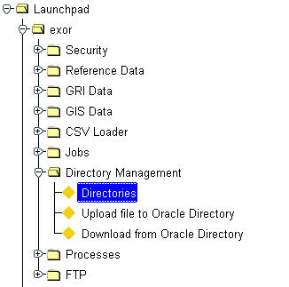

Figure 1
Directories menu

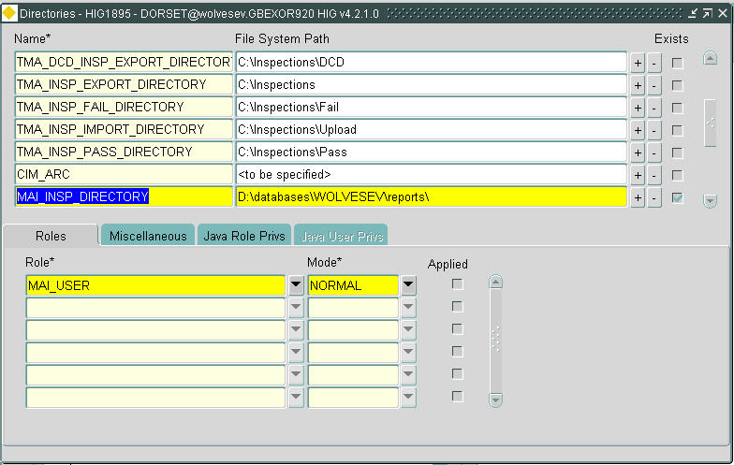

Figure 2
Directories

General Information
This form is used to enter a directory under the MAI_INSP_DIRECTORY option.

The directory specified is the directory on the server database that a selected file is uploaded to by the form when performing a manual inspection load. It is also the folder that the FTP polling process moves files to from the FTP site. The inspection loader then picks up the files from this directory and loads them into the database.

Name Mandatory
The name of available directories will be displayed.
For setting up the Inspection Loader the option MAI_INSP_DIRECTORY should be selected.

File System Path Required
Enter a valid directory that will be used in the inspection load process.

Exists Display Only
This option will be checked to show that the directory entered is a valid directory.

Roles Tab
Role Mandatory List
Enter the role that the user must be granted in order to write to the directory.

Mode Mandatory List
Enter the mode of access of the role defined that the user must be granted in order to write to the directory.

Maintenance Inspection Loader- MAI4400
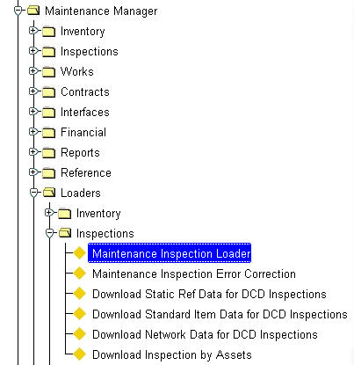
Figure 3
Maintenance Inspection
Loader
Menu option

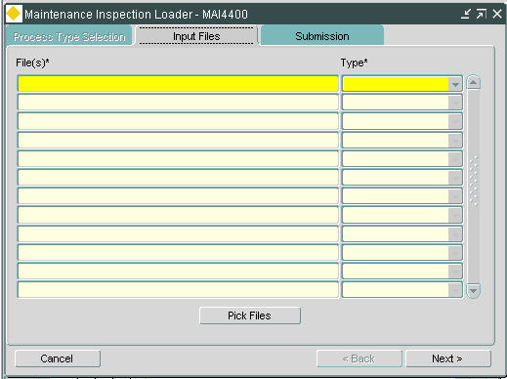
Figure 4
Maintenance Inspection
Loader

General Information
Inspection files can be loaded into maintenance manager in one of two ways. It can be done manually by picking the individual files for load or can be done automatically.
Note: For details of setting up an automatic process for inspection loading refer to the appropriate section of this document.

This form is used to manually load inspection files.
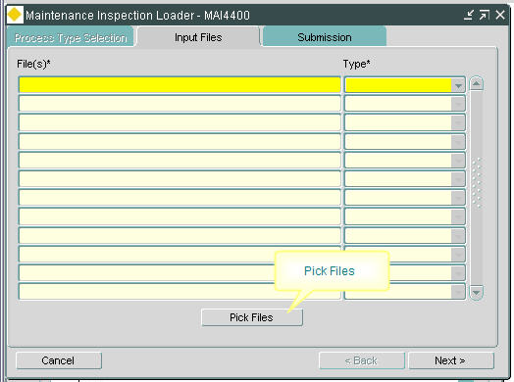

Figure 5
Input Files tab

Input Files
The Input Files tab is used to manually select a file to be processed through the inspection loader. The file to be loaded can be selected using the [Pick Files] button. This tab is enabled only if the selected process has input file types associated with it.

[Pick Files]
Press this button to bring up the ‘Select Files’ window where the inspection file to be loaded can be located and selected.
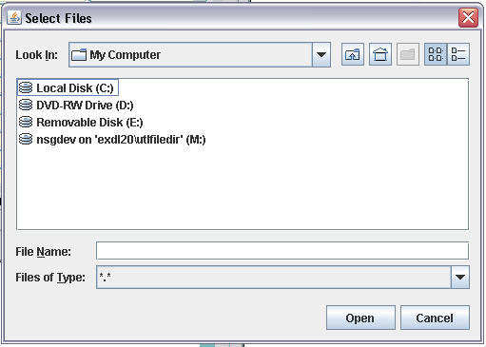

Figure 6
Select Files

Once the file has been located select the [Open] button to place it into the Input Files tab.
Files (Required)
This field will show the filename of the inspection file selected to be loaded.

Type (Required) List
Select the type of file to be loaded. This will be ‘Inspection Files’.

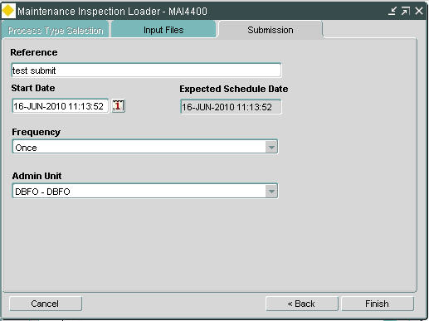

Figure 7
Submission tab

Submission
Selecting the [Next] button on the Input Files tab will open the Submission tab.
The [Cancel] button will cancel the load process.
The [<Back] button will take the form back to the Input Files tab.

Reference (Optional)
Enter a reference name for the inspection load submission.

Start Date (Required)
Enter the date and time the file should be processed. This will default to the current date and time.

Expected Schedule Date (Display Only)
This will show the date and time as defined in the ‘Start Date’ field.

Frequency (Required) List
The frequency of the inspection load submission will default to ‘Once’ for manual loading. Scheduling frequencies will have been set up previously in form Scheduling Frequencies – HIG2530.

Admin Unit (Optional) List
Enter the admin unit to be used for processing the inspection load file if required.

Select the [Finish] button to start the inspection load process.

The Process Created window will appear.

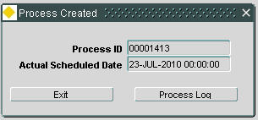
Figure 8
Process Created

Process Id (Display Only)
The process Id of the inspection load will be displayed.

Actual Scheduled Date (Display Only)
The actual date of the start of the process of the inspection load will be displayed.

[Exit] will exit the Maintain Inspection Loader form but the inspection load process will continue.

[Process Log] will open form Process Execution Log – HIG2540.

Process Execution Log – HIG2540
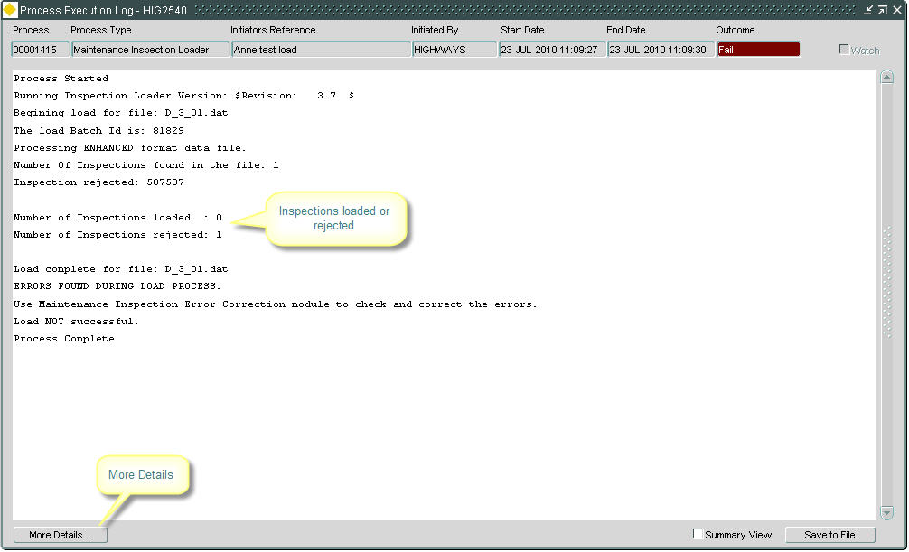

Figure 9
Process Execution Log

General Information
The Process Execution Log show details of the inspection load including the outcome of either ‘Pass’ or ‘Fail’. This form is for information only.

The Process Execution Log can be called from form Process Monitor – HIG2520 or by using the [Process Log] button in form Submit a Process – HIG2510 after a process has been submitted.

Process (Display Only)
The process number of the inspection load will be displayed.

Process Type (Display Only)
The process type of the inspection load as defined in form Maintenance Inspection Loader – MAI4400 will be displayed.

Initiators Reference (Display Only)
The reference of the inspection load as defined in form Maintenance Inspection Loader – MAI4400 will be displayed.

Initiated By (Display Only)
The name of the user that initiated the inspection load will be displayed.

Start Date (Display Only)
The start date and time of the inspection load will be displayed.

End Date (Display Only)
The end date and time of the inspection load will be displayed.

Outcome (Display Only)
The outcome of the inspection load will be displayed.
The main part of the form will show a log of all processes that have been carried out for that process Id. Details will include:

- Batch Id
- Errors found during load process
- Number of inspections found
- Number of inspections loaded
- Number of inspections rejected
- Load successful/not successful

If the inspection load was not successful and subsequently corrected and re-submitted the results will be added to the log.

Watch (Checkbox)
During execution the process execution log will continually add logging details to the screen as the process is taking place. It will re-query the log table every 3 seconds. For large processes there will be masses of details being logged.
Unchecking this box will stop the details from continually being written to the screen.

Summary View (Checkbox)
Select this box to reduce the contents of the log to a summary view.

For executions that have been completed the [Save to File] button will allow the contents of the process execution log to be saved to a specified location.
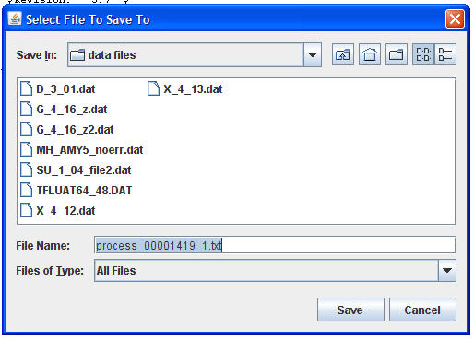

Figure 10
Save to File

The [More Details...] button will open form Maintenance Inspection Error Correction – MAI4405 from where unsuccessful files can be corrected and re-submitted. (For further details on maintenance inspection error correction refer to relevant section in this documentation.)

Maintenance Inspection Error Correction – MAI4405
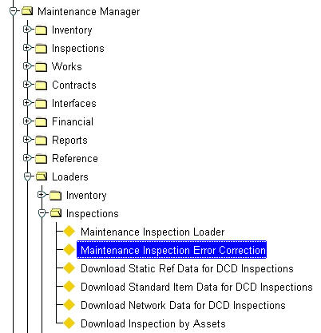
Figure 11
Inspection Error
Correction
Menu Option

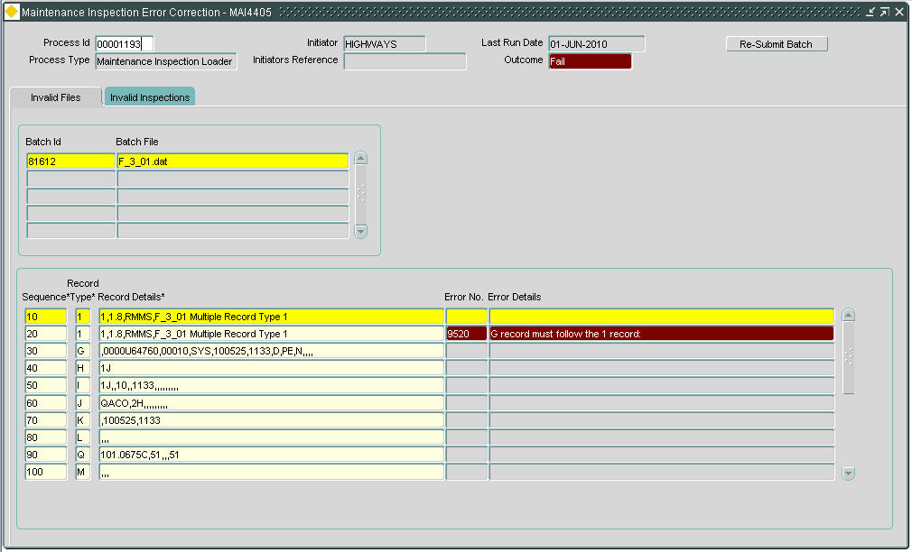
Figure 12
Inspection
Error Correction

General Information
This form is used to review and correct the load file after a failed load. Once the changes have been completed the file will have to be re-submitted using the [Re-Submit Batch] button.
The form can be opened from the Maintenance Manager menu or alternatively directly from form Process Execution Log – HIG2540 by pressing the [More Details] button.

Figure 13
Error Correction

Maintenance Inspection Error Correction
The first part of this form will display details of the inspection load process.

Process Id (Display Only)
The internal process Id for the batch load will be displayed.

Initiator (Display Only)
The name of the user who loaded the batch file will be displayed.

Last Run Date (Display Only)
The date the file was last processed will be displayed.

Process Type (Display Only)
This will display ‘Maintenance Inspection Loader’ for this type of load file.

Initiators Reference (Display Only)
The reference quoted in the file submission in form Maintenance Inspection Loader - MAI4400 will be displayed.

Outcome (Display Only)
The outcome will show either ‘Success’ or ‘Fail’ for completed inspection loads. For loads to be submitted at a later date the outcome will show ‘To Be Determined’.

Figure 14
Invalid Files
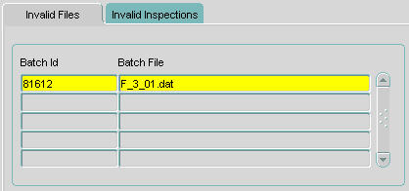

Invalid Files
As part of the load process the system performs basic validation checks on the file before the data is transferred. Some of the checks are:

- The basic format of the file is correct.
- Missing or misplaced ‘X’ records
- The first record of a file is a ‘G’ record.
- The total number of G, H, I, J, D, K, L, M, N, P, R and S records equal the totals in the X record which is the last record in the file.
- Mandatory fields are populated

If the batch file submitted is invalid details of the errors will be displayed under the ‘Invalid Files’ tab.

Batch Id (Display Only)
The Batch Id generated for the load will be displayed.

Batch File (Display Only)
The batch file name will be displayed.

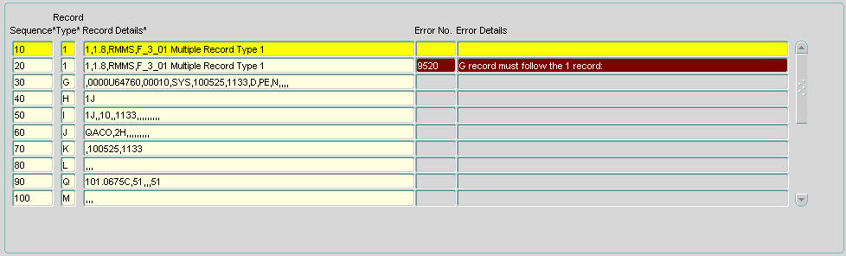
Figure 15
Record Information

Record Information
All data records for the selected batch file will be displayed. Data that has an error can be modified here prior to re-submitting the batch.

Sequence (Display Only)
The sequence number of the record within the file will be displayed.

Record Type (Display Only)
This field will display the record type. These types will have associated data in the adjacent field. Valid types are G, H, I, J, D, K, L, M, N, P, R, S and X.

Record Details (Display Only)
The details contained in this field will depend upon the record type in the previous field. Update the data in this field; the error message will give a guide as to what is wrong with the data.

Error No. (Display Only)
If the data is incorrect the error number will be displayed.

Error Details (Display Only)
Details of the error in the file will be displayed.

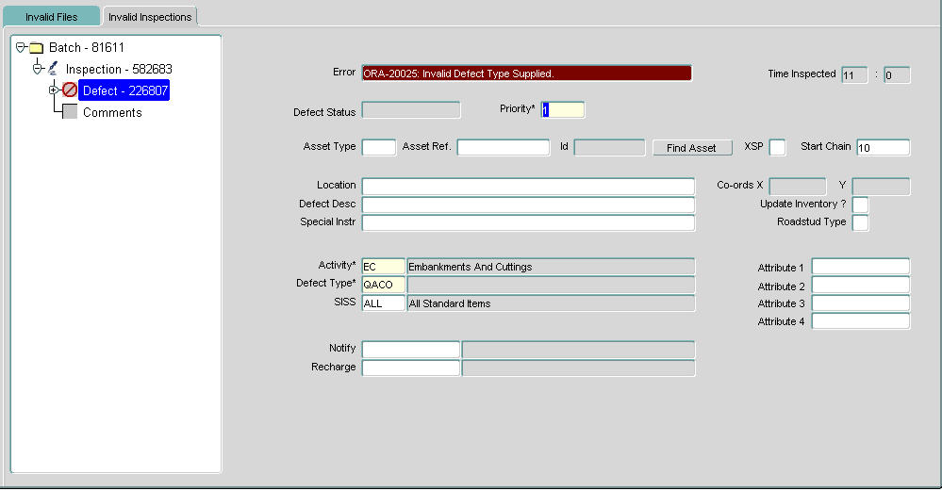

Figure 16
Invalid Inspections

Invalid Inspections
Once the file has passed the validation checks further more stringent validation checks are performed on the actual data. Some of these checks are:

- The network and associated chainage match what is held on the system.
- The treatment code, defect code and activity areas identified in the file exist in the system.
- The inspectors have been entered onto the system.
- Survey type and direction are correct.
- Complaint date, source code and source type are valid.
- Notifiable and rechargeable organisations exist.
Any data that does not pass the validation checks will be shown under the ‘Invalid Inspections’ tab.

Data that has an error can be corrected here prior to re-submitting the batch.

Batch (Display Only)
The batch file number that contains invalid data will be displayed.
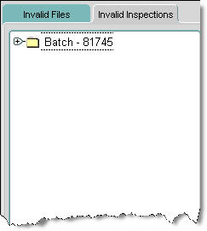

Figure 17
Invalid Inspections

Clicking on the + sign against the batch file number will show the inspection data contained in the batch.

Click on the + sign against the inspection and then against the defect to show further details of defect, repair and boq items.

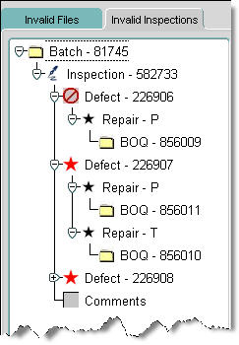
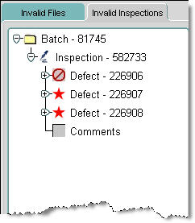
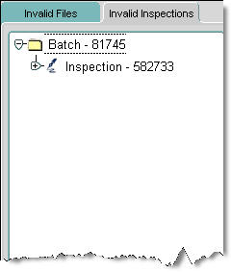
Figure 18
Invalid Inspections
tree

Invalid records will be identified with a red circle

Highlight the invalid record to open up details of the error on the right hand side of the form. The error can then be corrected and the file re-submitted using the [Re-Submit Batch] button.
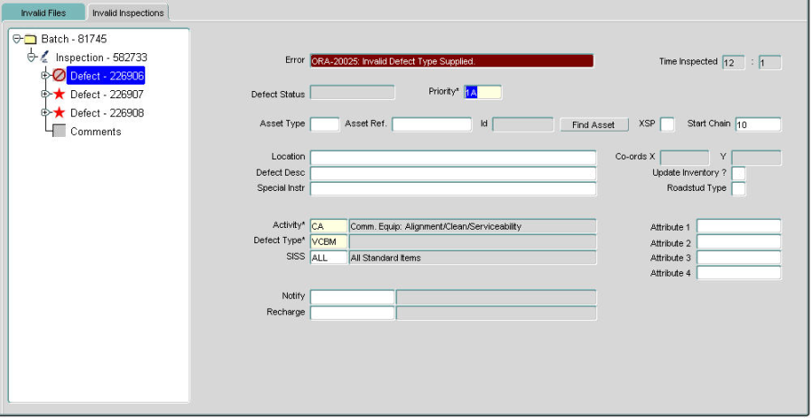
Figure 19
Invalid Inspections

Re-Submit Inspection
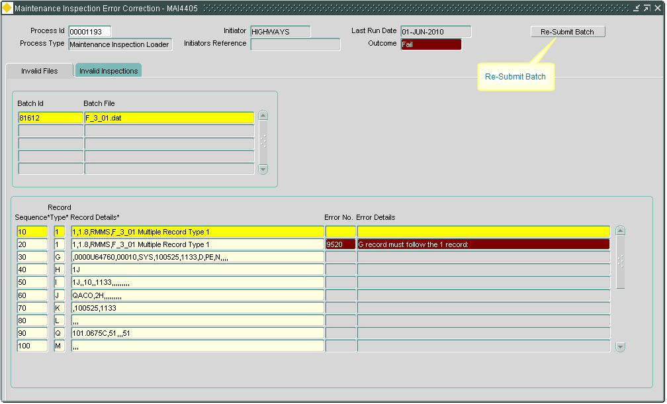

Figure 20
Re-submit Inspection

Once the [Re-Submit Batch] button is pressed the inspection will be processed using the same Process Id.

If errors are found a message will appear showing that the batch contains either invalid files or inspections.
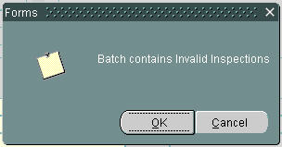

Figure 21
Error message

If on re-submit the inspection load is successful a message will appear as below.
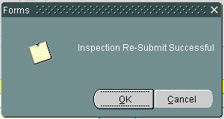

Figure 22
Success message

Examples of Error Correction
Invalid File - record count

The process execution log will show:
ERROR: record counts do not match terminator record.
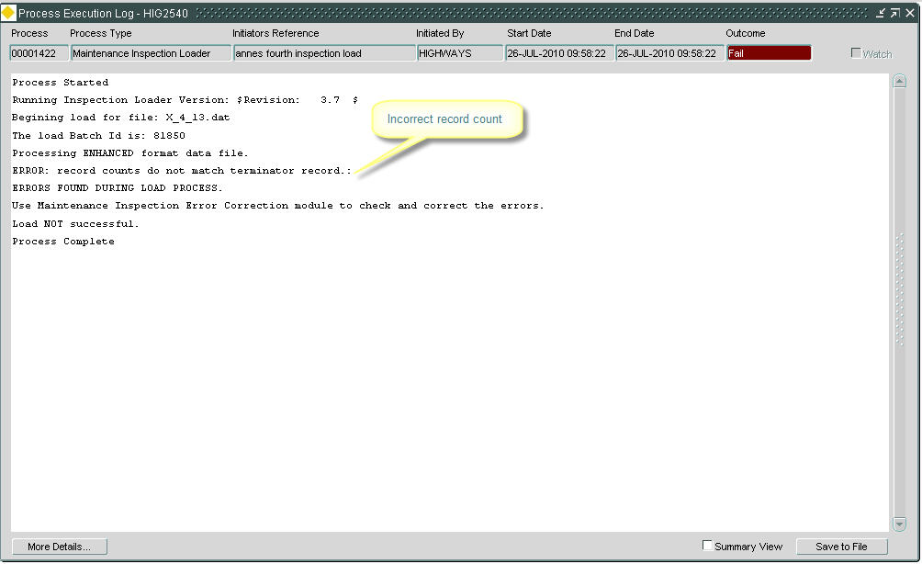

Figure 23
Process Execution
Log

This error means that the ‘X’ record count is incorrect.

Select the [More Details…] tab which will open at the Invalid Files tab.
Scroll down the record types to the last record (X record).
The X record should be amended to show the correct count and then saved.
The file can now be re-submitted using the [Re-Submit Batch] button.
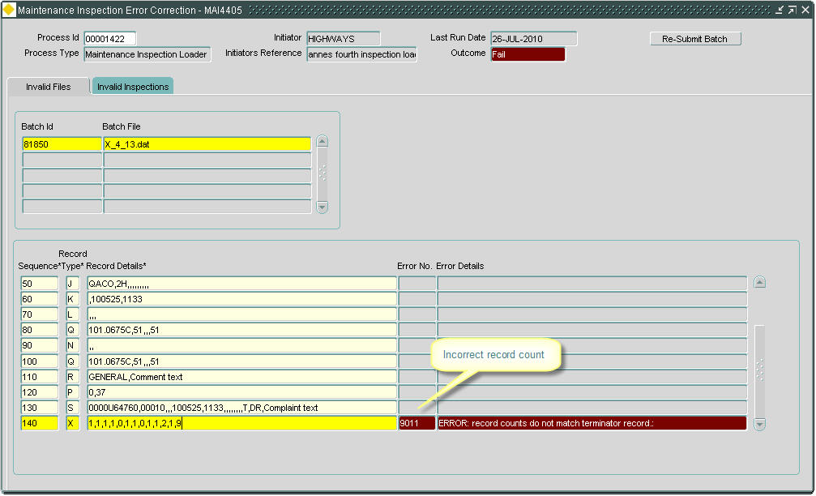

Figure 24
Maintenance Inspection
Error Correction

Invalid Inspection:

The process execution log will show:
e.g. Inspection rejected: 587537

Number of Inspections loaded: 0
Number of Inspections rejected: 1

Figure 25
Process Execution
Log

This error means that the there is an error an inspection contained within the batch.

Select the [More Details…] tab which will open at the Invalid Inspections tab.
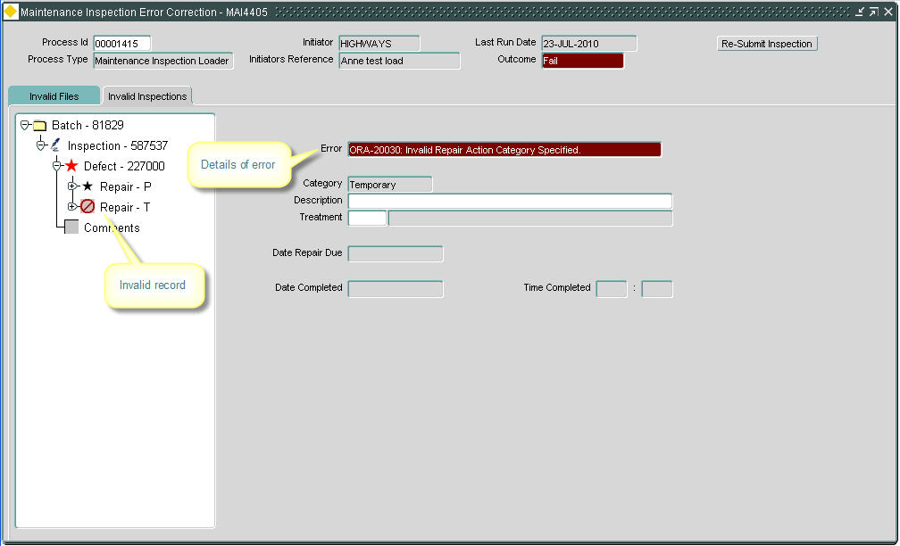

Figure 26
Maintenance Inspection
Error Correction

Click on the + sign against the batch file number to show the inspection data contained in the batch.

Click on the + sign against the inspection and then against the defect to show further details of defect, repair and boq items.

Invalid records will be identified with a red circle

Highlight the invalid record to open up details of the error on the right hand side of the form.

An invalid repair type can be removed from the file with the [Delete Record] button on the toolbar.

The record should then be saved and the file re-submitted using the [Re-Submit Batch] button.

Note: if the repair has an associated BOQ this record must first be deleted before the repair can be removed.

If the re-submit process is successful then a message will appear.
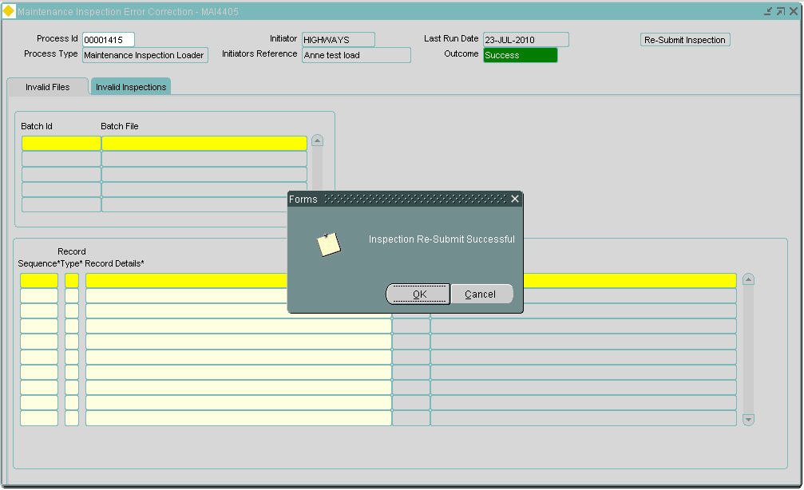

Figure 27
Success message

If further errors are encountered these should be corrected and the batch re-submitted until no errors remain.

Invalid Inspection:

The process execution log will show:
e.g. Inspection rejected: 587562

Number of Inspections loaded: 0
Number of Inspections rejected: 1
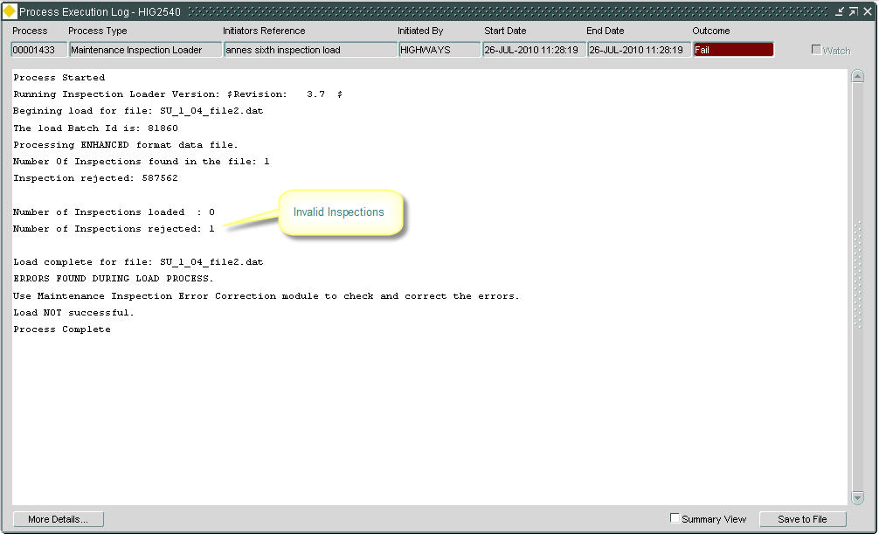

Figure 28
Process Execution
Log

This error means that the there is an error an inspection contained within the batch.

Select the [More Details…] tab which will open at the Invalid Inspections tab.
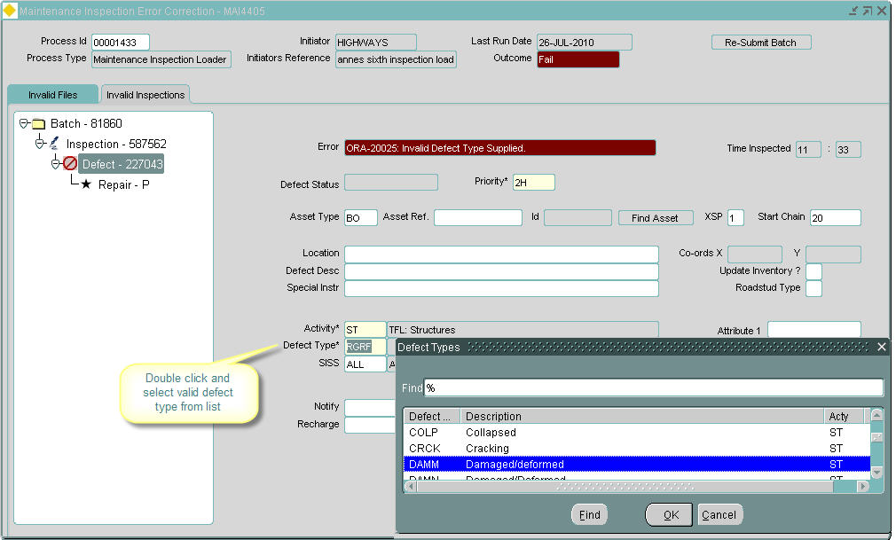

Figure 29
Invalid Inspections tab

Click on the + sign against the batch file number to show the inspection data contained in the batch.

Click on the + sign against the inspection and then against the defect to show further details of defect, repair and boq items.

Invalid records will be identified with a red circle

Highlight the invalid record to open up details of the error on the right hand side of the form.

For an invalid defect type, double click in the ‘Defect Type’ field and select a valid type from the list of values.

The record should then be saved and the file re-submitted using the [Re-Submit Batch] button.
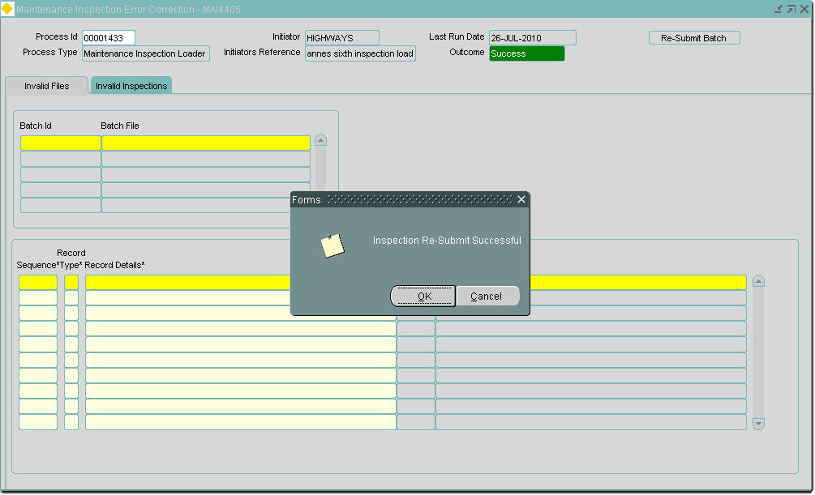

Figure 30
Success message

If further errors are encountered these should be corrected and the batch re-submitted until no errors remain.

Load Inspection Data – File Format
The following describes the data file format for loading inspection data into Maintenance Manager from exor’s data collection software (datacapture and MapCapture).

Introduction
The following fields will describe each record type.

Field
This column gives a descriptive name of the field.

DataType
This column may have the following values, which describes the allowable characters for the field.

Value | Description
Integer | Integer Number
Number | Number, decimal places
Alphanumeric | All Characters
Decimal Number | Number with decimal places

Max Size
This is the maximum size for this column.

M (mandatory)
If ticked this column is mandatory.

Description
This column will contain some meaningful text relating to the Field.

Record Types
All records must be enclosed by double quotes.
All Alphanumeric fields, with the exception of the Record Type, may also be optionally enclosed by double quotes (ASCII 34).
Items within the string are separated by commas.

‘1’ - Data File Information

Field | Datatype | Max Size | M | Description
Record Type | Alphanumeric | 1 | √ | Must contain “1”
Data Version | Alphanumeric | 10 | √ | Version Number “1.8”
Software Version | Alphanumeric | 10 |  | Software Version Number
File Type | Alphanumeric | 4 | √ | May contain one of the following values:  “RMMS” – Safety or Detailed Inspection  “ENHN” – Defect Survey (with optional BOQS)  “ASST” – Asset based survey
Description | Alphanumeric | 240 |  | Any useful description for the file

Example:
"1,1.8,4.1.122,ENHN,Inspection File 1"

‘G’ – Inspection Details (Beginning of Inspection Block)

Field | Datatype | Max Size | M | Description
Record Type | Alphanumeric | 1 | √ | Must contain “G”
rse_he_id (ne_id) | Integer | 9 | √ | Exor internal Id of the section
Link | Alphanumeric | 10 | √ | Agency/Link Code
Section | Alphanumeric | 3 | √ | Section number
First Inspector | Alphanumeric | 3 | √ | The Inspectors initials (as stored within the exor database)
Inspection Date | Alphanumeric | YYMMDD | √ | Date of inspection e.g.100129
Inspection Time | Alphanumeric | HHMM | √ | Time of the inspection e.g. 1503
Safety/Detailed | Alphanumeric | 1 | √ | D for Detailed or S for Safety
Initiation Type | Alphanumeric | 3 | √ | Any valid initiation type from the pedif file
Direction | Alphanumeric | 1 | √ | Inspection direction in relation to the section start node.  ‘Y’ indicates reverse direction  ‘N’ indicates forward direction
Second Inspector | Alphanumeric | 3 |  | The second Inspectors initials (as stored within the exor database.
Weather condition | Alphanumeric | 4 |  | Any valid weather condition from the pedif file e.g. FINE, FOG, RAIN, etc
Road Surface | Alphanumeric | 4 |  | Any valid weather condition from the pedif file e.g. DRY, WET, SNOW etc
Section Description | Alphanumeric | 240 |  | Section description

Example:
"G,,2300B62842,00010,LC,20040930,1408,D,NRM,N,,FINE,DRY,.Section Description."

‘H’ – Inspection Activities

Field | Datatype | Max Size | M | Description
Record Type | Alphanumeric | 1 | √ | Must contain “H”
Activity 1 | Alphanumeric | 2 | √ | Any valid Activity Code from the pedif file
Activity 2 | Alphanumeric | 2 |  | Any valid Activity Code from the pedif file
Activity 3 | Alphanumeric | 2 |  | Any valid Activity Code from the pedif file
Any number of activity mnemonics allowed in this record.

Example:-
"H,CW,FW,LP,MC,MH,SG"

‘I’ – Defect Location Details

Field | Datatype | Max Size | M | Description
Record Type | Alphanumeric | 1 | √ | Must contain “I”
Defect Activity | Alphanumeric | 2 | √ | Defect activity code
XSP | Alphanumeric | 1 |  | Cross sectional position of the defect
Chainage | Integer | 6 |  | Chainage of the defect
Location | Alphanumeric | 40 |  | Textual description of the defects location
Time | Alphanumeric | HHMM | √ | Time the defect was observed e.g. 1503
Identity Code | Alphanumeric | 8 |  | Identity code of the asset (sign, traffic signal, etc)
Diagram Number | Alphanumeric | 7 |  | Diagram number of the asset (sign etc)
Asset Type | Alphanumeric | 2 |  | Asset type of the associated asset
Inventory Change Indicator | Alphanumeric | 1 |  | Any valid value from the Asset Modification domain (included in the pedif file)
Marshall Sub-Head Code | Alphanumeric | 3 |  | Standard Item Sub Section (SISS) code
Notifiable Organisation | Alphanumeric | 10 |  | Notifiable organisation code
Rechargeable | Alphanumeric | 10 |  | Rechargeable organisation code
Special Instructions | Alphanumeric | 254 |  | Text field for any special instructions relating to the defect
Description | Alphanumeric | 240 |  | Defect description text field

Example:
"I,CW,5,415,EAST END OF ACCESS TO EDISCUM GARTH,1411,,,,,,,,Special Instruction, Large Pot Hole"

‘J’ – Additional Defect Details

Field | Datatype | Max Size | M | Description
Record Type | Alphanumeric | 1 | √ | Must contain “J”
Defect Type | Alphanumeric | 4 | √ | Defect type code
Priority | Alphanumeric | 4 | √ | Defect priority
Defect Category | Alphanumeric | 4 |  | Defect response category
Asset Id | Integer | 10 |  | External Id of the associated asset
Easting | Decimal Number | 38 (incl decimal point) |  | X co ordinate of the defect
Northing | Decimal Number | 38 (incl decimal point) |  | Y co ordinate of the defect
Attribute 1 | Alphanumeric (dependent on the attribute | Dependent on the column used by the attribute |  | Value for attribute 1 as defined against the defect type
Attribute 2 | Alphanumeric (dependent on the attribute | Dependent on the column used by the attribute |  | Value for attribute 2 as defined against the defect type
Attribute 3 | Alphanumeric (dependent on the attribute | Dependent on the column used by the attribute |  | Value for attribute 3 as defined against the defect type
Attribute 4 | Alphanumeric (dependent on the attribute | Dependent on the column used by the attribute |  | Value for attribute 4 as defined against the defect type
Road Stud Indicator | Alphanumeric | 1 |  | Road stud indicator  ‘M’ – indicates Mandatory  ‘A’ – indicates Advisory  This field should be NULL if the defect is not associated with a road stud

Example:
"J,CPOT,1,,,12345,54321,28,570,,,"

‘D’ – Defect Document Attachments

Field | Datatype | Max Size | M | Description
Record Type | Alphanumeric | 1 | √ | Must contain “D”
Type | Alphanumeric | 4 |  | Document type code (if not supplied the value of Product Option DEFDOCTYPE will be used
Title | Alphanumeric | 60 |  | Document title
Description | Alphanumeric | 2000 |  | Document description
Category | Alphanumeric | 8 |  | Document category code
Location | Alphanumeric | 30 |  | Document manager location name (if not supplied the value of Product Option DEFDOCLOCN will be used
Filename | Alphanumeric | 254 | √ | Name of the file to be attached

Zero or more D records can be specified for each Defect specified in the file.
In order to associate documents with a given Defect the D records must be positioned directly after the relevant J record in the file.

Example:
"D,PHOT,Before Photo,.Pot Hole, before repair.,,DEFECT_PHOTOS,def1001291501.jpg"

‘K’ – Immediate Action Details

Field | Datatype | Max Size | M | Description
Record Type | Alphanumeric | 1 | √ | Must contain “K”
Repair Description | Alphanumeric | 240 |  | Description of the Immediate action taken or recommended
Date Repaired | Alphanumeric | YYMMDD | √ | Date the Immediate action was taken
Time Repaired | Alphanumeric | HHMM | √ | Time the Immediate action was taken e.g. 1504 (24 hour format)

Example:
"K,MARKED UP,20040930,1411"

‘L’ – Temporary Action Details

Field | Datatype | Max Size | M | Description
Record Type | Alphanumeric | 1 | √ | Must contain “L”
Repair Description | Alphanumeric | 240 |  | Description of the Temporary action taken or recommended
Date Repaired | Alphanumeric | YYMMDD |  | Date the action was taken.  NULL if the action was not carried out at the time of the inspection
Time Repaired | Alphanumeric | HHMM |  | Time the Immediate action was taken e.g. 1504 (24 hour format)  NULL if the action was not carried out at the time of the inspection.
Treatment | Alphanumeric | 4 |  | Treatment code

Example:
"L,FILL POTHOLE,20041001,1600,PATG"

‘M’ – Permanent Category 1 Action Details

Field | Datatype | Max Size | M | Description
Record Type | Alphanumeric | 1 | √ | Must contain “M”
Repair Description | Alphanumeric | 240 |  | Description of the permanent action taken or recommended
Date Repaired | Alphanumeric | YYMMDD |  | Date the action was taken.  NULL if the action was not carried out at the time of the inspection
Time Repaired | Alphanumeric | HHMM |  | Time the Immediate action was taken e.g. 1504 (24 hour format)  NULL if the action was not carried out at the time of the inspection.
Treatment | Alphanumeric | 4 |  | Treatment code

Example:
"M,PATCH AREA,,,FTPR"

‘N’ – Permanent Category 2 Action Details

Field | Datatype | Max Size | M | Description
Record Type | Alphanumeric | 1 | √ | Must contain “N”
Repair Description | Alphanumeric | 240 |  | Description of the permanent action
Treatment | Alphanumeric | 4 |  | Treatment code
Sub Category | Integer |  |  | Not used in EID format files

Example:
"N,POTHOLE FORMING LANE 2,/PRI,0001"

‘Q’ – BOQ Details

Field | Datatype | Max Size | M | Description
Record Type | Alphanumeric | 1 | √ | Must contain “Q”
Item Code | Alphanumeric | 10 | √ | Item code
Dimension 1 | Number | 10,2  (99999999,99) | √ | First dimension of the item  If the value supplied has a precision greater than the specified maximum of 2 decimal places it will be rounded
Dimension 2 | Number | 10,2  (99999999,99) |  | Second dimension of the item  If the value supplied has a precision greater than the specified maximum of 2 decimal places it will be rounded
Dimension 2 | Number | 10,2  (99999999,99) |  | Third dimension of the item  If the value supplied has a precision greater than the specified maximum of 2 decimal places it will be rounded
Quantity | Number | 10,2  (99999999,99) | √ | Total quantity i.e. the product of the specified dimensions

Zero or more Q records (BOQs) can be specified for each Temporary or Permanent Action specified in the file (BOQs are not allowed on Immediate Actions).
In order to associate BOQs with a given Action the Q records must be positioned directly after the relevant Action record in the file.
Example:
"K,MARKED UP,20040930,1411"
"L,FILL POTHOLE,20041001,1600,PATG"
"Q,1011106,0.92,,,0.92"
"Q,1008101,0.8,0.8,,0.6400000000000001"
"M,PATCH AREA,,,FTPR"
"Q,1008102,2.3,0.6,,1.38"

‘R’ – Comments

Field | Datatype | Max Size | M | Description
Record Type | Alphanumeric | 1 | √ | Must contain “R”
Comment Class | Alphanumeric | 8 | √ | Document category
Comment Text | Alphanumeric | 240 | √ | The test to be recorded as the comment

Example:
"R,GENERAL,BACK STREET NOT INSPECTED"

‘P’ – End of Inspection Block

Field | Datatype | Max Size | M | Description
Record Type | Alphanumeric | 1 | √ | Must contain “P”
Start Chainage | Integer | 6 | √ | Chainage at the start of the inspection
End Chainage | Integer | 6 | √ | Chainage at the end of the inspection. The value 999999 will be interpreted as the end of the section being inspected

For an RMMS safety survey the Start Chainage must be 0 and the End Chainage must be 999999

Example:
"P,0,999999"

‘X’ – End of File

Field | Datatype | Max Size | M | Description
Record Type | Alphanumeric | 1 | √ | Must contain “X”
G | Integer | 38 | √ | Count of ‘G’ records in the file
H | Integer | 38 | √ | Count of ‘H’ records in the file
I | Integer | 38 | √ | Count of ‘I’ records in the file
J | Integer | 38 | √ | Count of ‘J’ records in the file
D | Integer | 38 | √ | Count of ‘D’ records in the file
K | Integer | 38 | √ | Count of ‘K’ records in the file
L | Integer | 38 | √ | Count of ‘L’ records in the file
M | Integer | 38 | √ | Count of ‘M’ records in the file
N | Integer | 38 | √ | Count of ‘N’ records in the file
P | Integer | 38 | √ | Count of ‘P’ records in the file
Q | Integer | 38 | √ | Count of ‘Q’ records in the file
R | Integer | 38 | √ | Count of ‘R’ records in the file
S | Integer | 38 | √ | Count of ‘S’ records in the file

Example:
"X,4,4,15,15,0,0,0,0,15,4,0,0,0"
The values can be zero padded e.g.
"X,0041,0041,0038,0038,0000,0000,0038,0000,0041,0000,0009,0000"

